PL NewCo Applications

Monitoring Handbook

Version 1.0

## 

## 

## Change History

| Version  # | Date Created/ Changed  (MM/DD/YY) | Prepared/ Modified  By | Reason and Details of Change | Internally Reviewed By |
| --- | --- | --- | --- | --- |
| V 1.0 | 03/05/2023 | HIG Leads, PS Alert & Monitoring Team | Initial Version | Patturi, Kishore |

Table of Contents

Change History 2

Purpose of the Document 4

Sanity Check 4

Sales Router: 6

Billing URL: 7

User Admin: 8

Internal Policy 8

Policy Monitoring for CSR User 9

Steps for View policy, View Policy Details, and Customer 360 10

iv). click on ‘View Customer 360’​ and verify Billing Card, Policy Card 13

Billing Monitoring for CSR User 18

Corelogic and BRCC Home Inspection 20

NJ Carco 21

App2App Batches 22

Real Time DP/APIC, Claims & Balancing 25

Billing Checklist 27

3PD Services 28

Duck Creek Splunk Dashboard – Performance 29

Daily Renewal Batch monitoring 31

System Errors 34

BRCC Balancing Issues 37

Certificate Upgrade 39

MTE Ticket Extract Report 42

SF Details 44

External Security Checks 45

IP Tracking 45

MFT Job Status – On Prem 46

New Volumetric Prod Dashboard 48

Grafana for Performance 49

## Purpose of the Document

The document provides summary of various monitoring and alerting steps tools and procedures instrumented on the applications within Personal Lines.

|  |  |  |
| --- | --- | --- |
| **SR .1** | **Sanity Checks** | **Hartford & Shared Mailbox** |

## Sanity Check

**Descriptions** – This task is performed to check the overall Application Availability. Team checks the following functionalities a) Quote creation for Auto & Home LOB is working fine, b) Policy Monitoring, c) Sales Router getting routed to each zip codes, d) Billing URL, e) CSR Monitoring for Policy & Billing.

* Quote creation for Auto & Home LOB:

URL: <https://www.thehartford.com/>

Credentials: Not needed, one can directly launch website by entering above URL. You need to provide Zip code for Auto and Home product and verify if Upfront Product Selection Page is getting loaded successfully. Please find the list of Zip codes used against the NewCo States:





LOB Personal Auto – SS



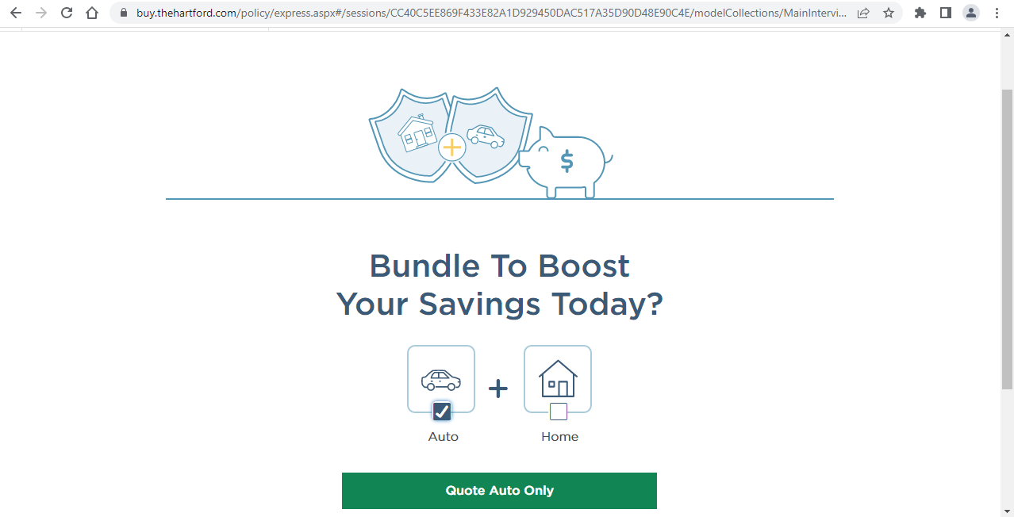

LOB Personal Home – SS

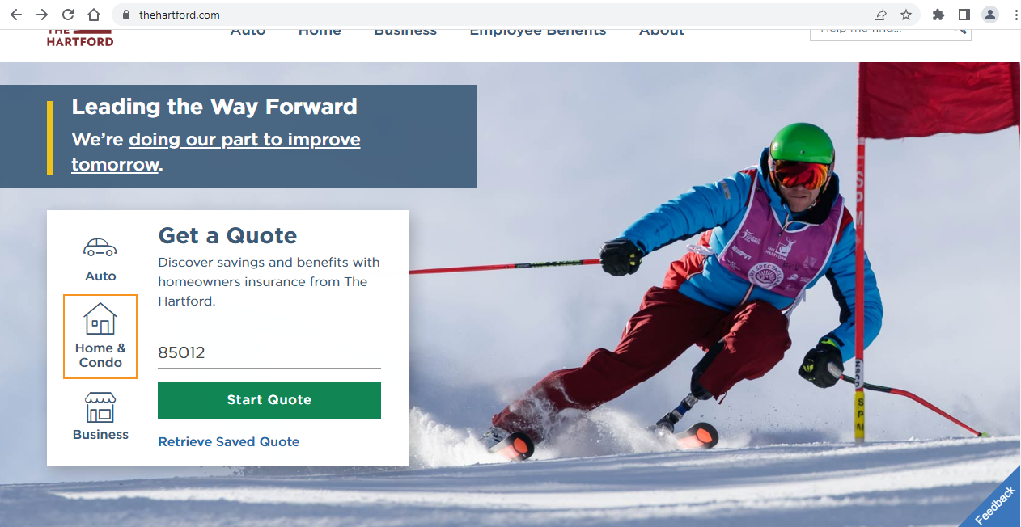

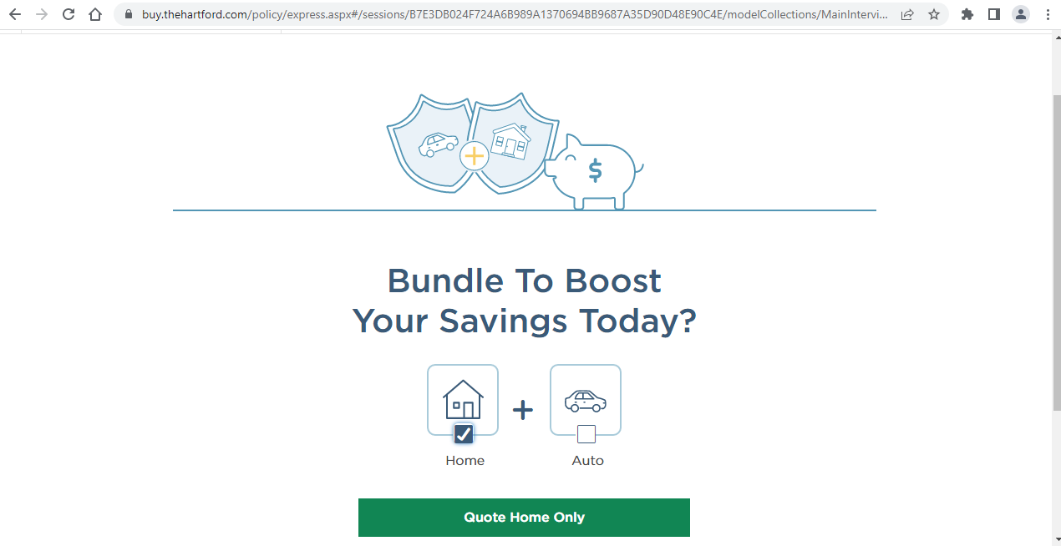

### Sales Router:

URL: <https://www.thehartford.com/>

Credentials: Not needed, we can directly start as below

**Steps:**

* Please enter any Zip code other than NewCo Go-LIVE States e.g., CA - 90210, click on Start Quote button.



* User should be navigated to the NowCo Quote page

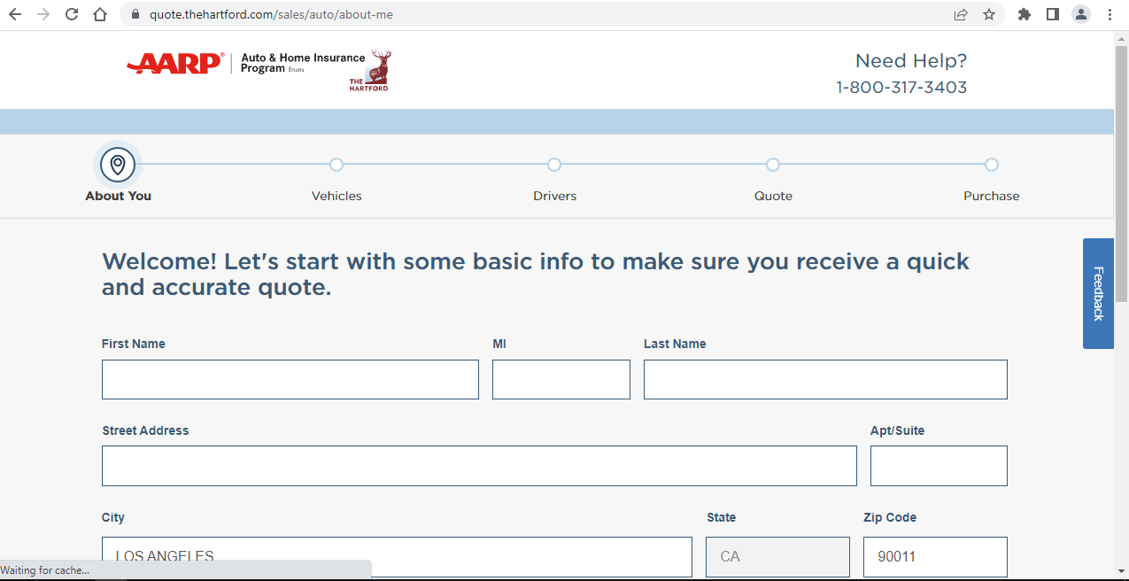

### Billing URL:

URL: <https://internalbuy.thehartford.com/billing/default.aspx>

* You need to verify whether the URL is accessible & loading successfully

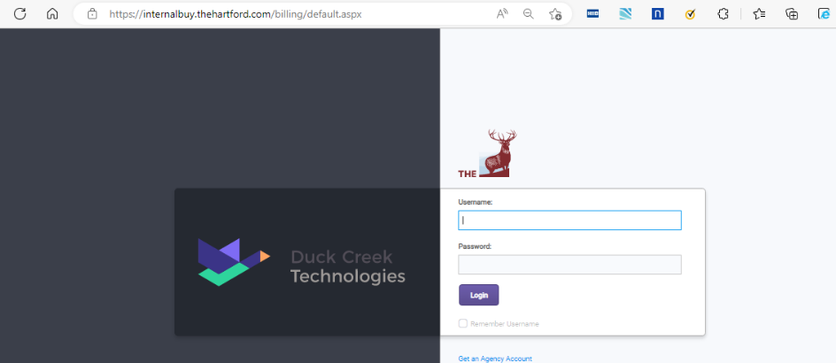

### User Admin:

URL: <https://internalbuy.thehartford.com/UserAdminPolicy/default.aspx>

-Please verify whether the URL is accessible & loading User Admin site

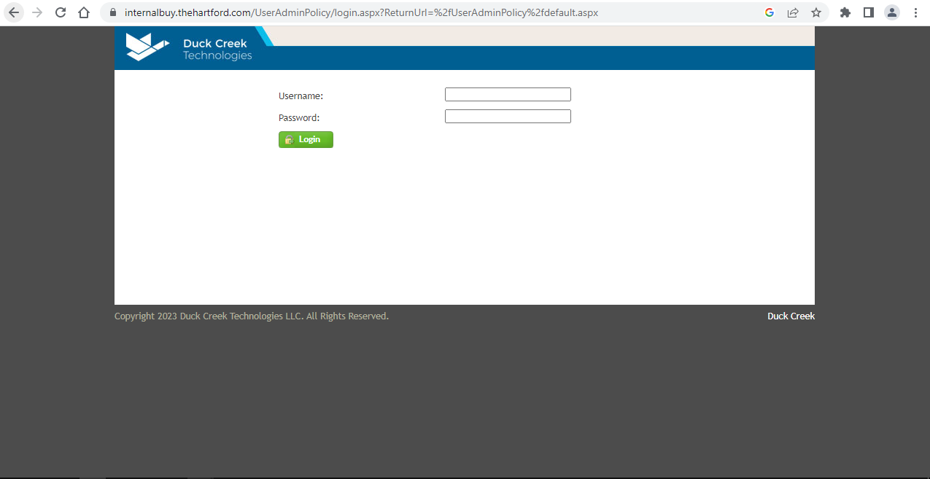

### Internal Policy

URL: <https://internalbuy.thehartford.com/policy/express.aspx>

-Please verify whether the URL is accessible & loading the page

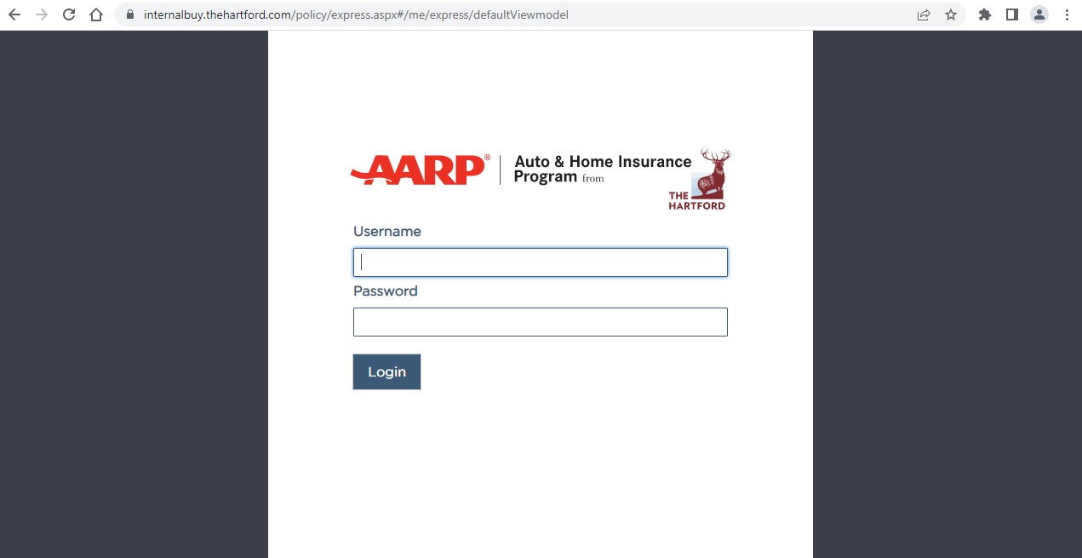

## Policy Monitoring for CSR User

URL: <https://smfederation.thehartford.com/affwebservices/public/saml2sso?SPID=DuckCreekPolicy>

-Search any existing PROD Policy number and it should be searchable. One needs to have CSR access to validate this.

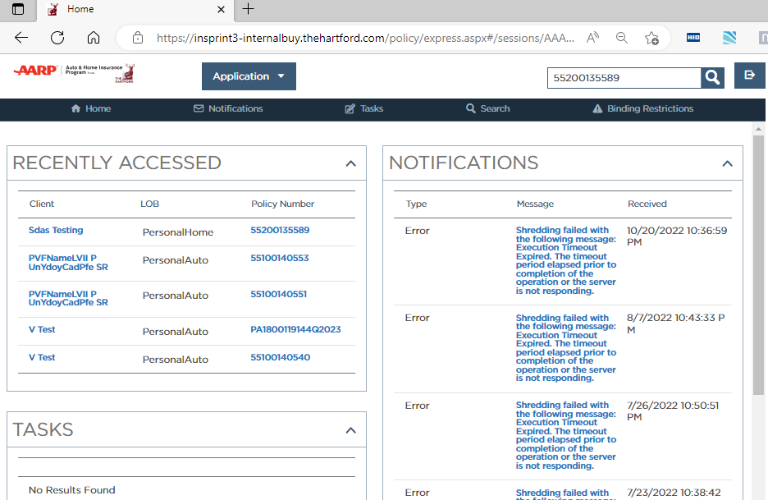

## Steps for View policy, View Policy Details, and Customer 360

i)You need to navigate or load Transact page when user search for the Policy

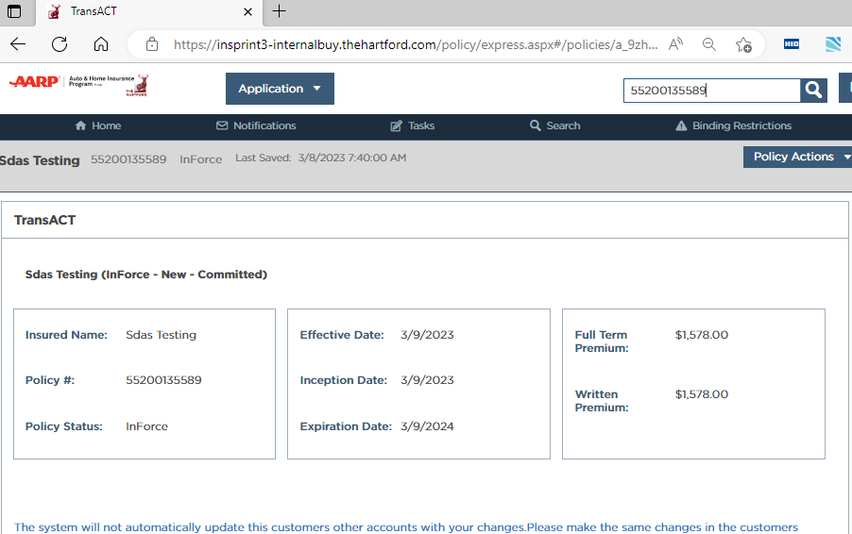

II). Click on ‘Policy Actions’ dropdown which is present on the top-right side of page

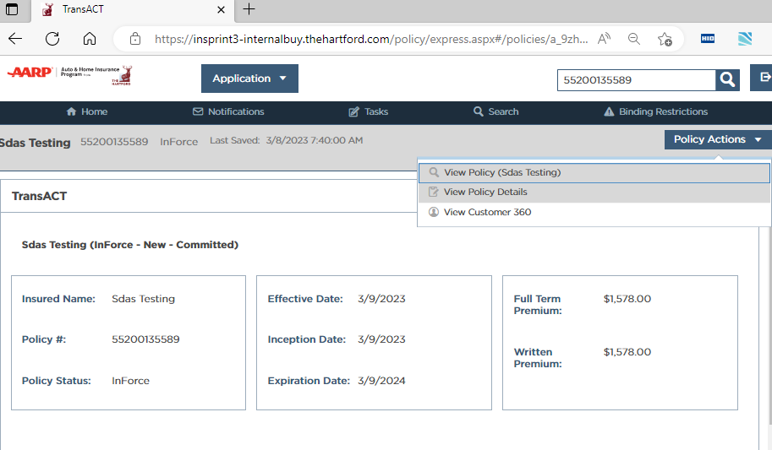

iii). click on ‘View Policy details and verify all section like – Notes, etc.

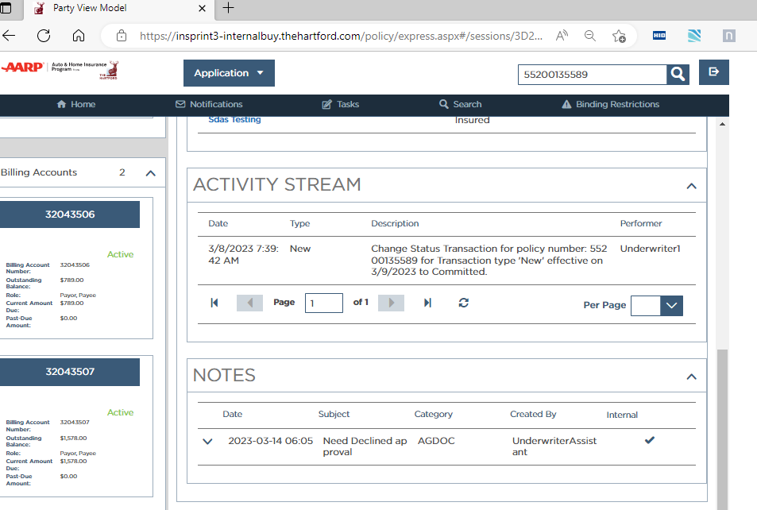

## iv). click on ‘View Customer 360’​ and verify Billing Card, Policy Card



v). Policy Card:

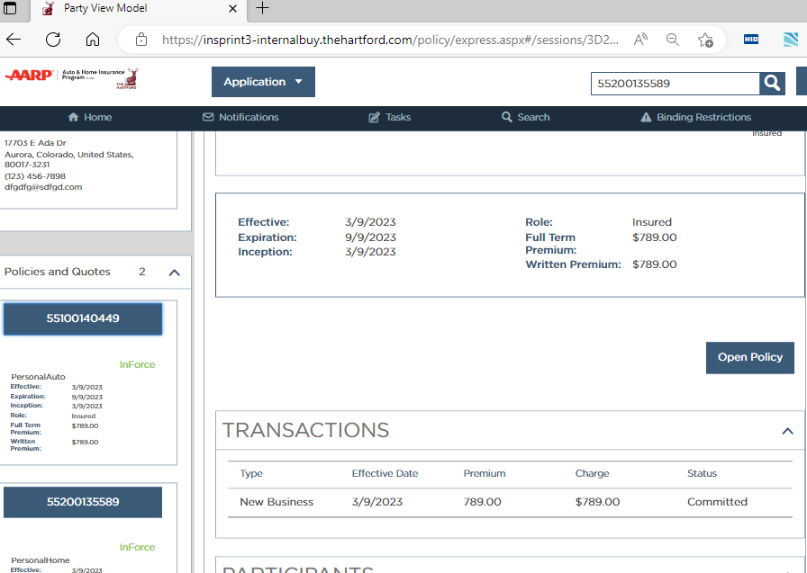

vi). Billing Card

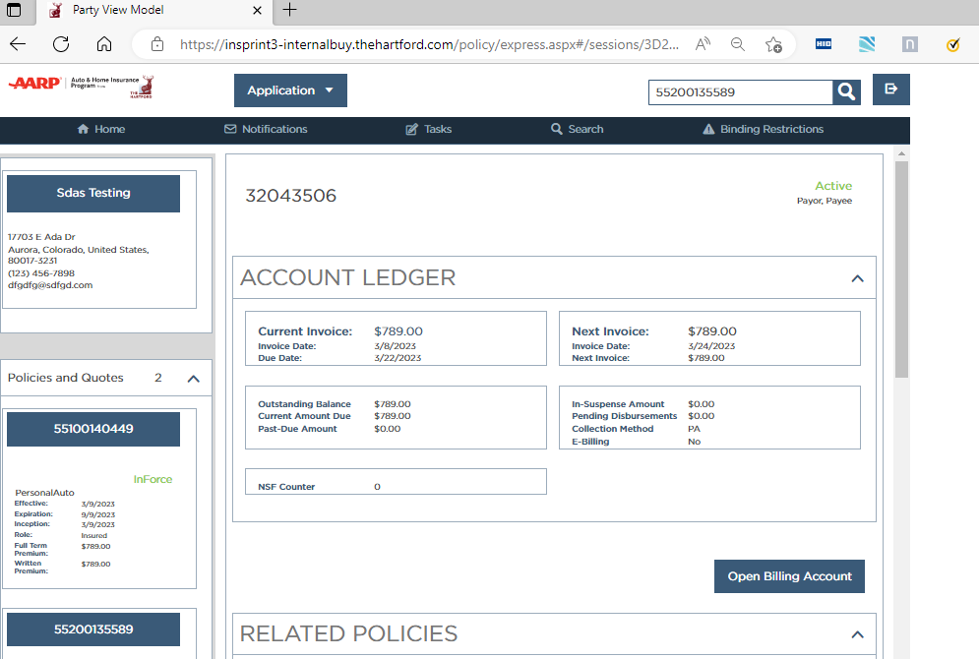

vii). Search click on Party and search Party Name.

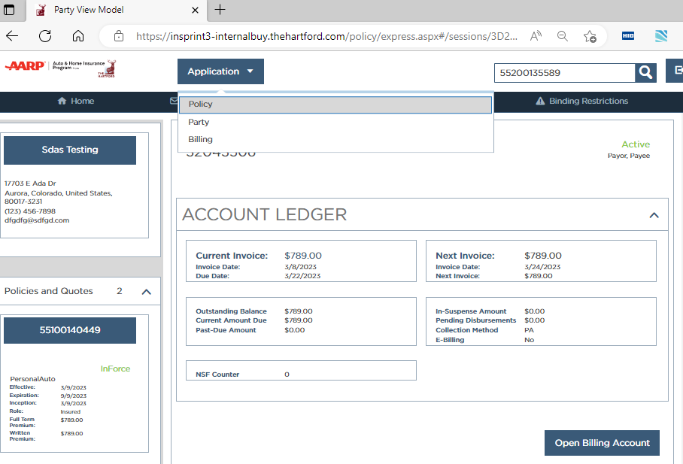

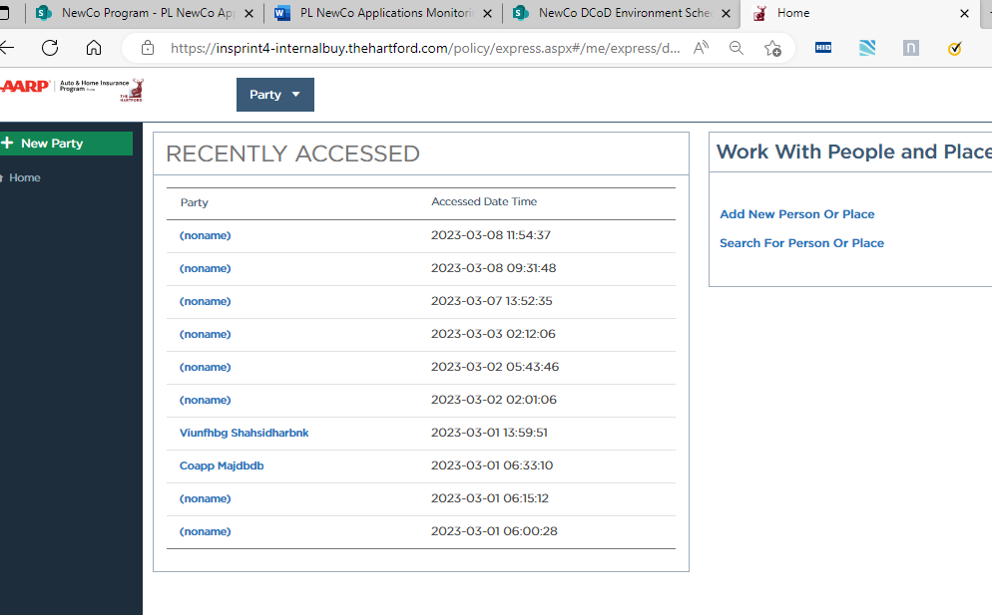

## Billing Monitoring for CSR User

-Search for Billing Account (mentioned below URL) and it should be searchable

**URL** : <https://internalbuy.thehartford.com/billing/default.aspx>

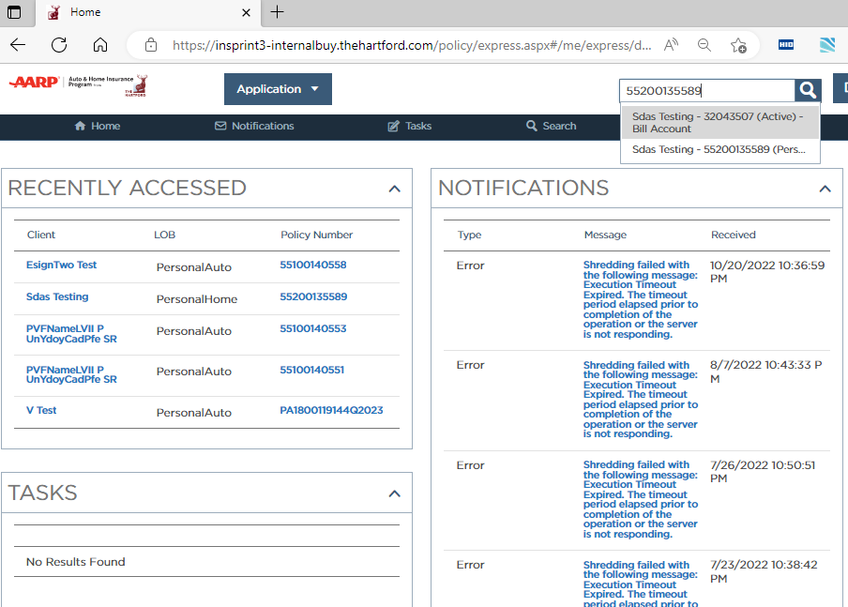

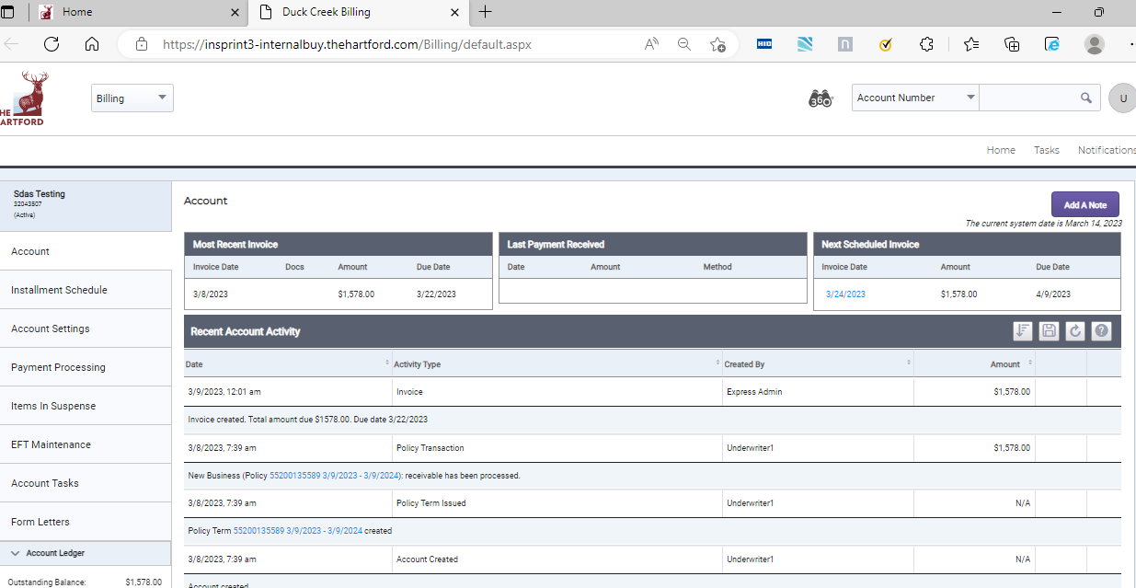

**B) Policy Batches**

**Description** – Team monitors **PL NEWCO PROD ALERTS** mailbox for any Policy batch related errors

.

**C)** **Billing Batches**

**Description -** Team monitors **PL NEWCO PROD ALERTS** mailbox for any Billing batch related errors

**D)** **Party Error**

**Description -** Team checks & monitors DCOD Error Log table to get a Party Error details.

|  |  |  |
| --- | --- | --- |
| **SR .2** | **Core Logic & BRCC Home Inspection** | **CoreLogic Daily Jobs & Alert Mailbox** |

## Corelogic and BRCC Home Inspection

**Description -** Team validates the list of Corelogic vendor files successfully processed through CoreLogic daily job. Along with the same, team verifies the count of successful home inspection balancing from BRCC. In case of any issue found, team shares the failures with respective POC.

Steps used: Post 6:00 AM EST daily, team verifies DCOD Prod Alerts mailbox for the counts shared by Corelogic and Home Inspection team:

Corelogic:

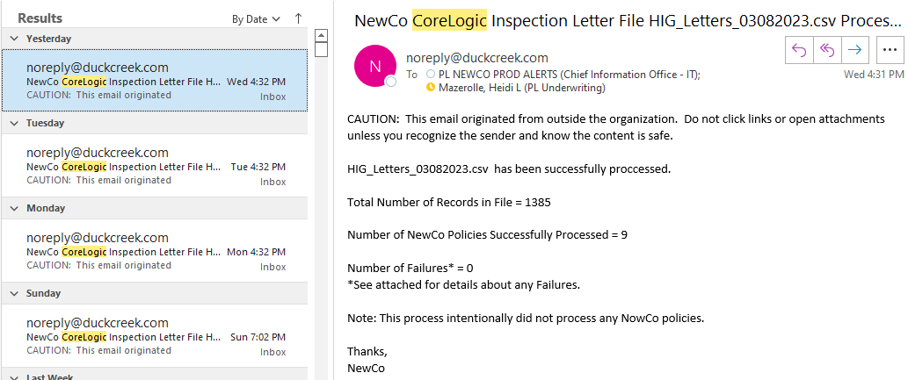

Home Inspection:

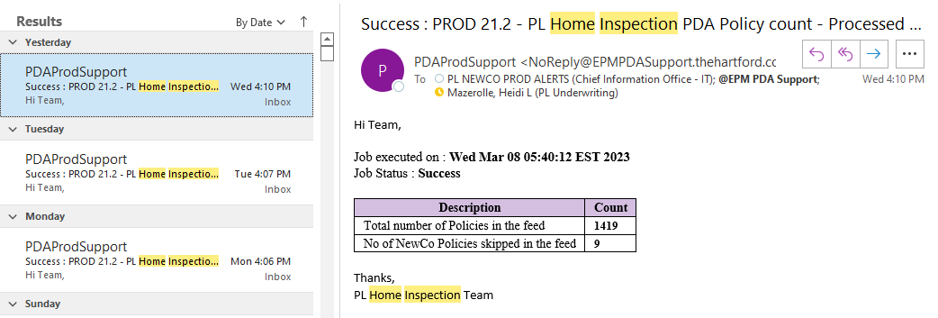

* After that, team reconfirms the count in Database. Home Inspection balancing from BRCC can also be found from AFS. Failure can be found from Carrier_2ExtendedLogging_Messages for Level 2 XML for DocGen service

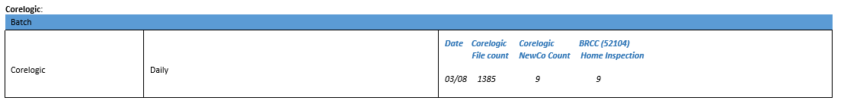

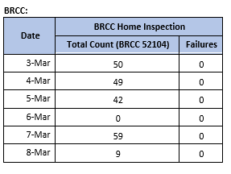

|  |  |  |
| --- | --- | --- |
| **SR .3** | **NJ Carco** | **Sql & Spreadhseet** |

### NJ Carco

**Description -** Implementation team is working on enhancing NJ Carco Batch job to handle the scenario where Policy Number is blank and to schedule the job not to run on weekends as per vendor file delivery. Team validates the batch job on daily basis to identify if any blank Policy number is present in the file. In case of exception team reports to the vendor for recovery.

Approach

1. Team checks the Success/Failures for CarCo batch in the extended logging messages table.

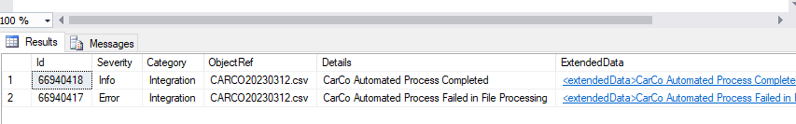

1. Validates the daily file sent in following path: \\ad1.prod\hig\PL\newco-prod\DCExchange\CarCo\Inbound, open the spreadsheet for a particular date and check if blank policy number field is present and prepares the report accordingly.

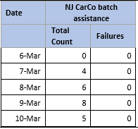

|  |  |  |
| --- | --- | --- |
| **SR .4** | **Batch Summary** | **Splunk Dashboard & SQL** |

### App2App Batches

**Description -** This dashboard is used to monitor all the 5 App2App batches: Stager, Transient, Persistent, Generator, Balancer. We can see the timings of all the batches, logs of each run of all the batches, the error (and its details) which we receive for each batch. Also, the Autosys logs which trigger these batches can be monitored through the dashboard.

Dashboard Link: Search | Splunk 9.0.2209.4 (splunkcloud.com)

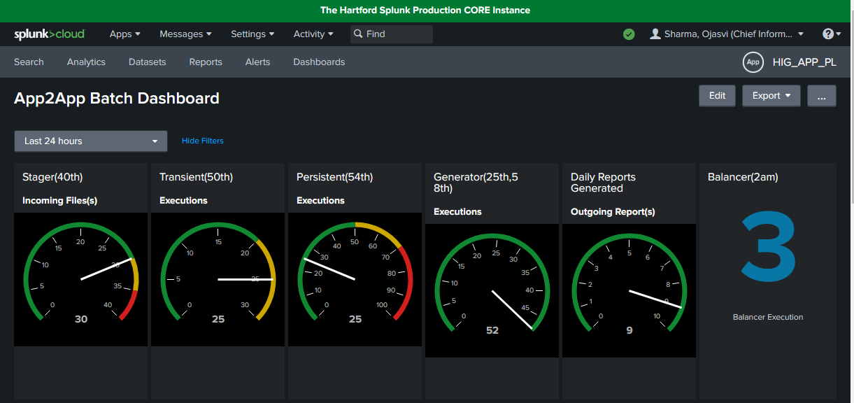

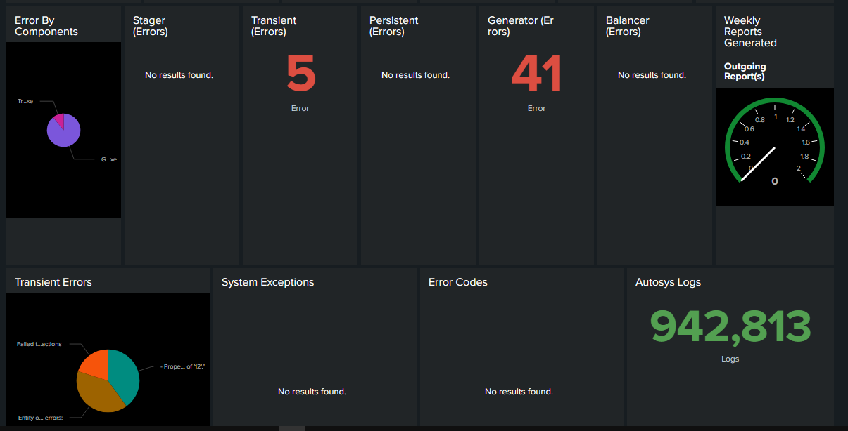

* Steps taken when we receive failure in the App2App Batches:

1. Whenever, we encounter any Stager failure like SSIS Job goes on HOLD due to duplicate transaction in the Feed file and the App2App Prod DB, then we recognize

the duplicate transactions and raise ODCH to ignore the transactions causing the issue and resume the Job.

1. When we encounter any Transient failure for a particular transaction, team analyzes the issue and raise Production defect.
2. At the time of Persistent failure, we raise RITM to switch ON the Persistent in App2App App_config table and raise RITM to recover the transactions which are failed due to the Persistent failure.
3. For Generator, when we have any report failure, we analyze the cause of the failure and raise the Prod defect and retrigger the report generation for that date by raising RITM. For transaction level failure in Generator Layer, we check the REPORT_EXCEPTION table and analyze the issue and accordingly raise defect.
4. **NPPS Batches**

**Description -** This dashboard is used to monitor all the 5 NPPS batches: Stager, Transformer, Generator, Balancer, RDM Refresh. We can see the execution details of all these batches, logs of each run of all the batches, the error (and its details) which we receive for each batch. Also, the Autosys logs which trigger these batches can be monitored through the dashboard.

‘NPPS - Personal Lines Batch Errors’ Splunk Link: [Search | Splunk 9.0.2209.4 (splunkcloud.com)](https://thehartford.splunkcloud.com/en-US/app/HIG_APP_PL/search?s=%2FservicesNS%2Fnobody%2FHIG_APP_PL%2Fsaved%2Fsearches%2FNPPS%2520-%2520%2520Personal%2520Lines%2520Batch%2520Errors&display.page.search.mode=verbose&dispatch.sample_ratio=1&workload_pool=standard_perf&q=search%20index%3Dapp_pl%0A(%20source%3DD%3A%5C%5Cpl%5C%5CNPPS%5C%5CPROD%5C%5CLogs%5C%5CBalancer%5C%5CBalancer.json%0AOR%20source%3DD%3A%5C%5Cpl%5C%5CNPPS%5C%5CPROD%5C%5CLogs%5C%5CStager%5C%5CStager.json%0AOR%20source%3DD%3A%5C%5Cpl%5C%5CNPPS%5C%5CPROD%5C%5CLogs%5C%5CFileGenerator%5C%5CFileGenerator.json%0AOR%20source%3DD%3A%5C%5Cpl%5C%5CNPPS%5C%5CPROD%5C%5CLogs%5C%5CTransformer%5C%5CTransformer.json%20)%0Alevel%20IN%20(%22ERROR%22%2C%20%22FATAL%22)&earliest=-24h%40h&latest=now&sid=1678351237.23623_E9B61837-3EE4-4015-AD65-57E9E0F3BEFF)

* Steps taken when we receive failure in the NPPS Batches:

1. Whenever, we encounter any Stager failure like SSIS Job goes on HOLD due to duplicate transaction in the Feed file and the NPPS Prod DB, then we perform the analysis to identify the duplicate transactions. Once done we raise ODCH to ignore the transactions causing the issue and resume the Job.
2. When we encounter any **Transformer** failure for a particular transaction, team analyzes the issue and raise Prod defect.
3. For File Generator, when we have any NPPS report failure, we analyze the cause of the failure and raise the Prod defect and retrigger the report generation for that date by raising RITM.
4. **Infoservice (Auto) Data**

**Description -** The dashboard that is used to monitor all the Infoservice Auto batch job errors.

We can see the timings of all the batches, logs of each run of all the batches, the error (and its details) which we receive for each batch. Also, the Autosys logs which trigger these batches can be monitored through the dashboard.

Note - The Infoservice file gets triggered only once in a week that is on Sunday unless we make manual intervention to run the Infoservice job.

Dashboard link- <https://thehartford.splunkcloud.com/en-US/app/HIG_APP_PL/auto_infoservice_batch_dashboard__prod?form.field1.earliest=-7d%40h&form.field1.latest=now>

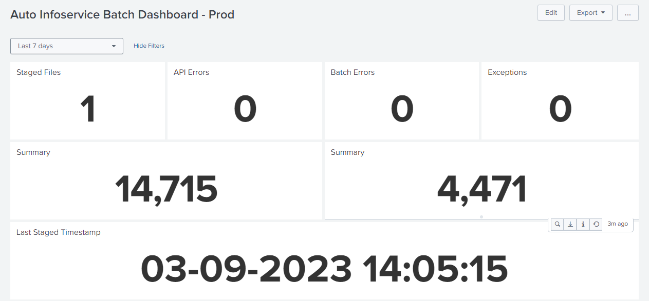

* Steps taken when we receive failure in the Infoservice Batches:

i) Whenever we encounter that the Infoservice Feed file is present in Inbound folder but not triggered then team will analyze the issue and raise RITM to trigger the Infoservice job.

ii) If we encounter any Infoservice errors then team will analyze the issue and take the necessary actions like raising the defects, discussion with the appropriate teams or raising RITM.

**D) Insights Purge**

**Description -** This data is collected to monitor the Weekly Insights Purge activity which purges the data from the Custom table present in Data Insights database.

* Approach: It is collected using SQL scripts

Report Screenshot



|  |  |  |
| --- | --- | --- |
| **SR .4** | **Real Time DP/APIC, Claims & Balancing** | **Email & Splunk Dashboard** |

## Real Time DP/APIC, Claims & Balancing

1. **DP/APIC (ESIGN (DP/ APIC), HomeRoof, HomeGrid), Agero, Safelight, APIC - newco policy search/inquiry/ info, Balancing**

**Description -** Team captures summary of Errors for Real Time APIs like – DP/APIC, Claims & Balancing. Team performs analysis & raise defects wherever required. Furthermore, Tracking of Defects is being taken care.

Structure of this table is as below –

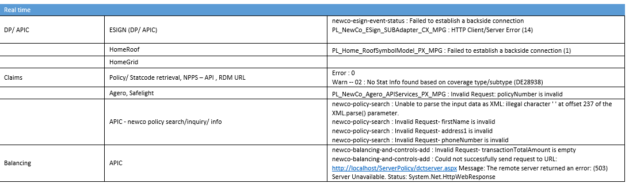

* Steps as Follows –

i) Collect alerts from PL NEWCO Prod Alert mailbox using APIC and WSM.  
ii) Get the service name and error message from the mail for reporting.

1. **Claims Stat API Dashboard**

**Description - This dashboard is used to monitor all the claims errors.**

**Claims Stat API Dashboard Splunk Link :** [**Claims Stat API Dashboard | Splunk 9.0.2209.4 (splunkcloud.com)**](https://thehartford.splunkcloud.com/en-US/app/HIG_APP_PL/claims_stat_api_dashboard?form.field2.earliest=-24h%40h&form.field2.latest=now&form.field1.earliest=-24h%40h&form.field1.latest=now&form.field4.earliest=-24h%40h&form.field4.latest=now&form.field3.earliest=-24h%40h&form.field3.latest=now&form.field5.earliest=-24h%40h&form.field5.latest=now&form.field6.earliest=-24h%40h&form.field6.latest=now&form.field14.earliest=-24h%40h&form.field14.latest=now&form.field15.earliest=-24h%40h&form.field15.latest=now&form.field16.earliest=-24h%40h&form.field16.latest=now&form.field17.earliest=-24h%40h&form.field17.latest=now)

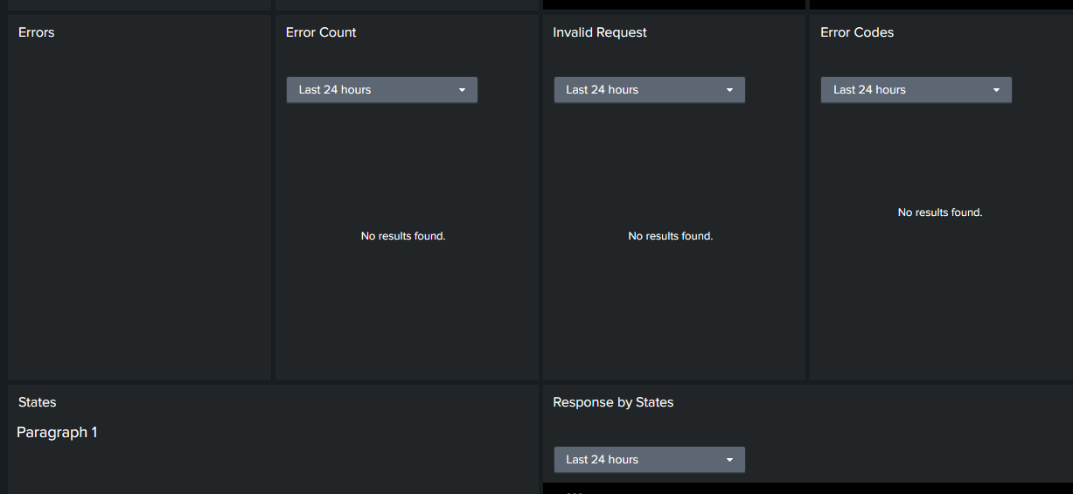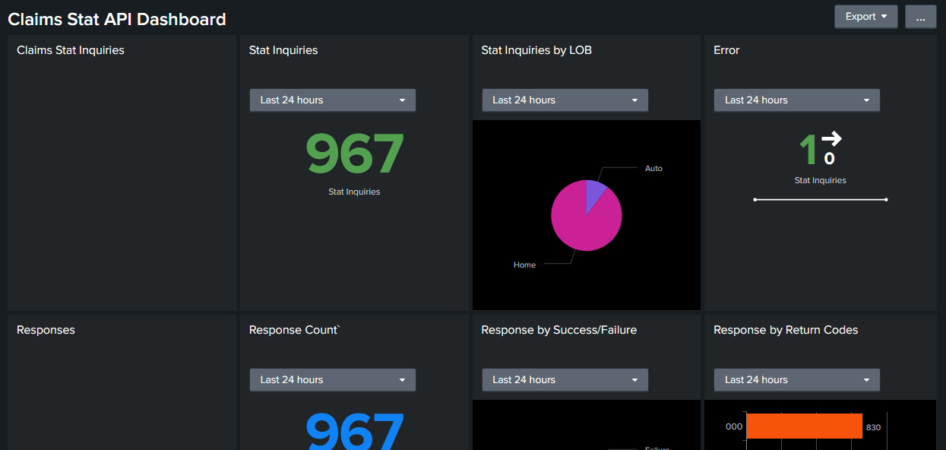

* Steps taken when we receive claims Error:

Whenever, we encounter any claims Error (with error codes: 501,502,503,504,505,506)  
team analyzes the issue and update the below tracker accordingly. Also we raise Prod defect if needed.  
  
[ClaimsStatAPI_Tracker.xlsx (sharepoint.com)](https://thehartford.sharepoint.com/:x:/r/sites/NewCoProgram/_layouts/15/doc2.aspx?sourcedoc=%7B0F1D3B85-F4B6-45FA-A0FE-A6CA46112918%7D&file=ClaimsStatAPI_Tracker.xlsx&action=default&mobileredirect=true&isSPOFile=1&clickparams=eyJBcHBOYW1lIjoiVGVhbXMtRGVza3RvcCIsIkFwcFZlcnNpb24iOiIyNy8yMjA3MzEwMTAwNSIsIkhhc0ZlZGVyYXRlZFVzZXIiOmZhbHNlfQ%3D%3D&cid=750af619-d834-4e0b-8c1c-45cc43cb6843)

|  |  |  |
| --- | --- | --- |
| **SR .5** | **Billing Monitoring Checklist** | **SQL Query, AFS, MFTPortal & Email** |

## Billing Checklist

**Description –** Team Monitor Billing Transactions for Newco Application. More Insights below

i) Section 1: All Processing exception which got logged in last 24 hours in DC_BIL_ProcessingExceptions for Billing. Which give us information for missing transactions in Billing and any critical issue occurring in system.

ii) SECTION 2: Payment Batch Failure details (DC_BIL_PaymentBatch), look for payment batch failure in last 24 hrs. (from Monday look or last 72 hrs.)

iii) SECTION 3: Bank ID issue need to run in morning to validate any bank id conflict, in case we got any EFTTransmissionId with bankID conflict we must raise ODCH request to correct the same.

iv) SECTION 4: Payment wallet issue where payment id is deleted, but collection not set to paper. In such case we must report affected account to Business to take appropriate actions.

v) SECTION 5: Lockbox monitoring, we can find any pending lockbox file .LBX which is not yet processed from AFS folder, by logon to Microsoft Azure Storage Explorer on file location.

vi) SECTION 6: We can check the count of Billing docs sent to BRCC for printing, and failures as well in case there.

vii) SECTION 7: Scheduled Activity stuck with 'I' status: To check whether the jobs were in complete status for stuck in between process.

viii) SECTION 8: Monitor Billing jobs from PL NEWCO ALERT shared mailbox for last 24 hours.

and as per the alerts we got we can validate the logs by manually checking AFS logs files.

1. **Billing Checklist Template**

|  |  |  |  |  |  |
| --- | --- | --- | --- | --- | --- |
| **Billing Monitoring Check List** | | | | | |
| **Processing Exception** | We received alert for: [Refer Section 1] | | | | |
| **ExceptionTypeCode** | **ExceptionReferenceId** | **Description** | **Comments** | **Assigned Team** |
| <ExceptionTypeCode> | <ExceptionReferenceId> | <Description> | <DefectID> | <Team who working on Defect> |
| <ExceptionTypeCode> | <ExceptionReferenceId> | <Description> | <DefectID> | <Team who working on Defect> |
| **Payment Batch Failure** | [Refer Section 2] | | | | |
| **Validate any bank id conflict** | [Refer Section 3] | | | | |
| **Payment wallet issue where payment id is deleted, but collection not set to Paper** | [Refer Section 4] | | | | |
| **Lockbox monitoring queries** | [Refer Section 5] | | | | |
| **BRCC Balancing Failure (Billing)** | [Refer Section 6] | | | | |
| **Scheduled Activity stuck with 'I' status** | [Refer Section 7] | | | | |
| **Billing Jobs** | [Refer Section 8] | | | | |

|  |  |  |
| --- | --- | --- |
| **SR .6** | **3PD Services** | **SQL Query & Splunk Dashboard** |

## 3PD Services

**Description -** There are 65+ third-party services. Team checks the health of all the services on daily basis from the previous day 4 AM EST to the next day 4 AM EST.

Data is extracted from Carrier_ExtendedLogging_Messages table of consolidated database and thirdpartyxmldata table of staging database. Team generates a report regarding the total calls, total number of failures and the type of error/error message for all the third-party services. Services are sorted in descending order of the failures.

Based on the number of failures, Team performs Analysis and raises defect if required or follow up with the vendor.

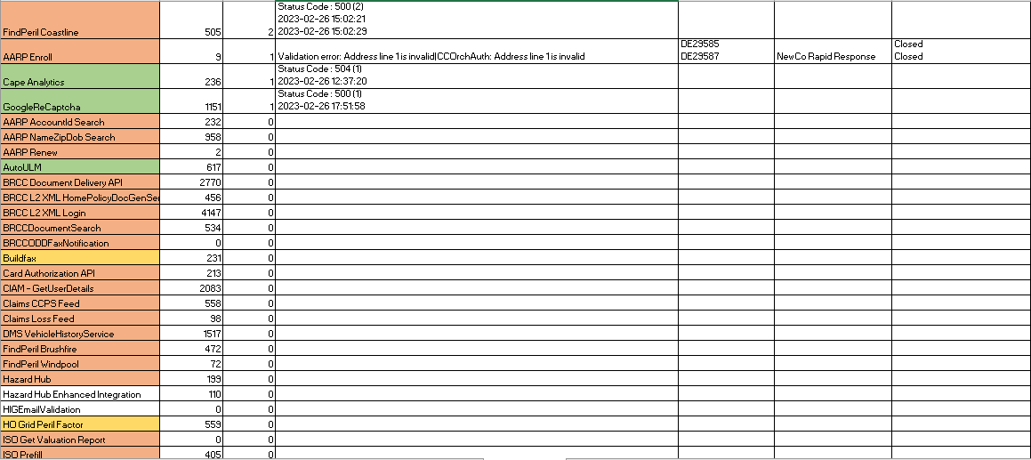

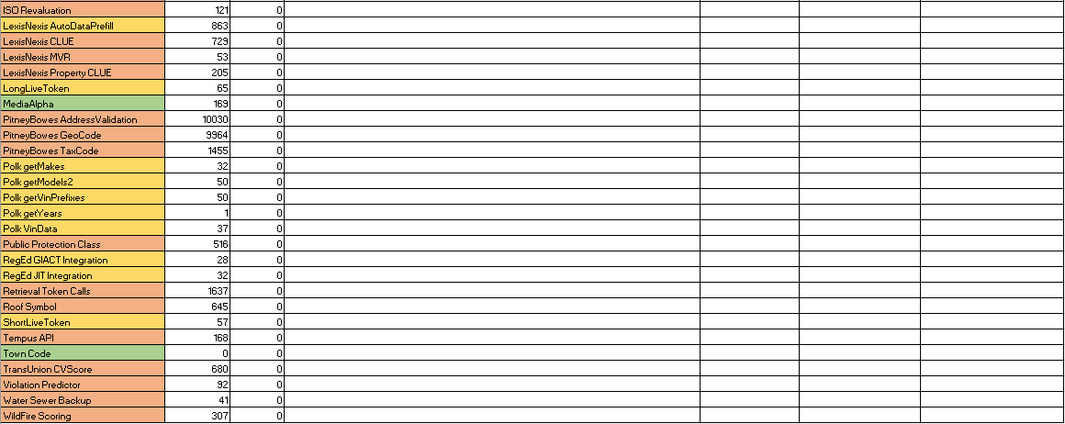

|  |  |  |
| --- | --- | --- |
| **SR .7** | **Additional Services - Splunk Dashboard** | **Splunk** |

## Duck Creek Splunk Dashboard – Performance

**Description -** This dashboard provides the performance metrices (in percentage) of processor time, memory usage, used space, average %CPU over time and average % memory over time for individual hostname.

URL: [Performance Dashboard | Splunk 9.0.2209.3 (splunkcloud.com)](https://dct.splunkcloud.com/en-US/app/test_iFrameDemo/performance_dashboard?form.target_domain=dct_metrics_prod&form.hostname_ui=UEPRD28APP23)

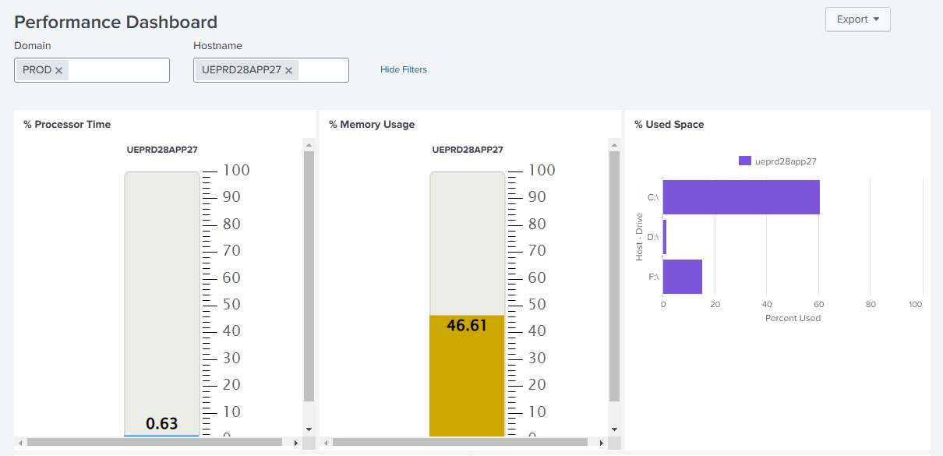

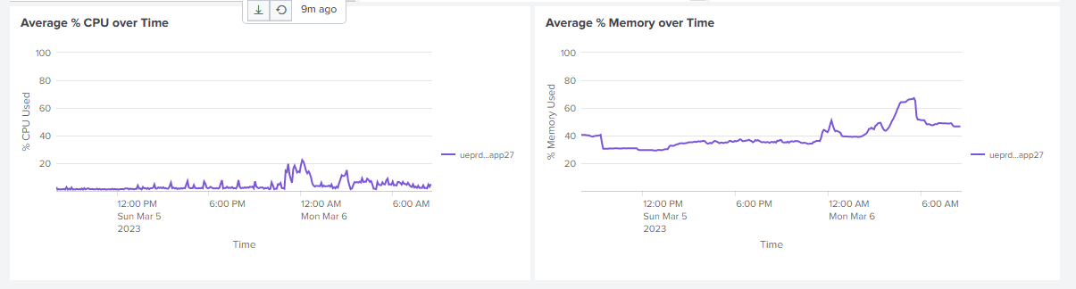

1. **Duck Creek Splunk Dashboard – Event**

**Description -** Team monitor Duck Creek Application events through this dashboard. It provides Event Counts by Application over Time, Event Message %, Event Count by Application, Event Details.

URL: [Event Dashboard | Splunk 9.0.2209.3 (splunkcloud.com)](https://dct.splunkcloud.com/en-US/app/test_iFrameDemo/event_dashboard?form.time_ui.earliest=-15m&form.time_ui.latest=now&form.target_domain=dct_*_prod&form.hostname_ui=*&form.event_detail_search=*&form.log_severity=*&form.application_name=*&form.correlationid_search=*&form.message_title_search=*)

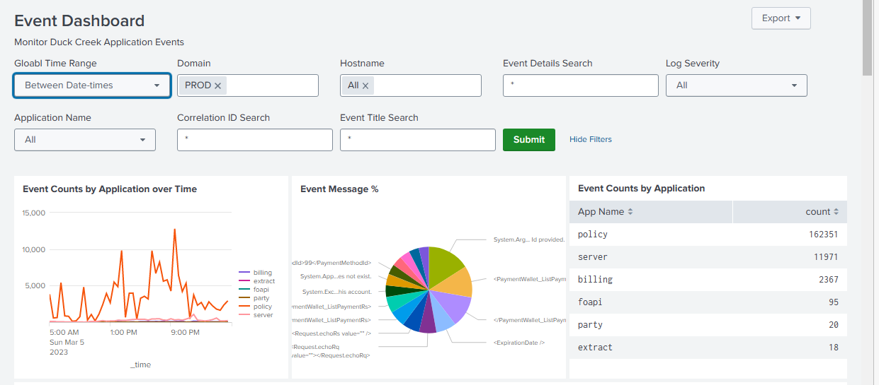

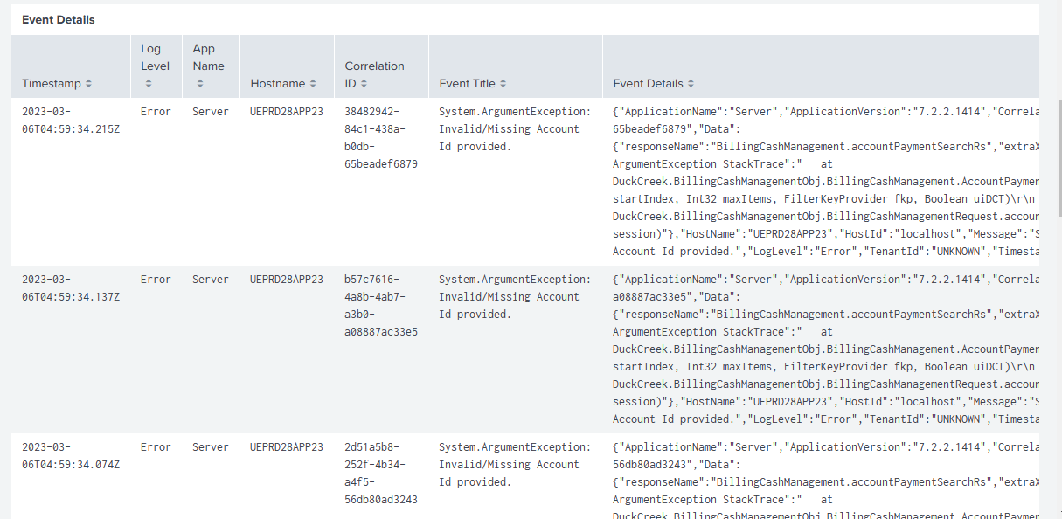

|  |  |  |
| --- | --- | --- |
| **SR .8** | **Renewal Batch** | **SQL Query** |

## Daily Renewal Batch monitoring

**Description -** Daily renewal batches are executed on policies that renew annually or on some other recurring basis. These batches typically consist of automated processes and scripts that run every day and are designed to handle the various tasks and workflows involved in renewing policies.

Some of the key tasks that may be included in daily renewal batches include:

* Policy renewal: The batch may be responsible for identifying policies that are due for renewal and automatically renewing them if the policyholder has not made any changes or cancelled their policy.
* Premium calculation: The batch may calculate the premium amounts for each policy based on factors such as the insured value, deductible, and any discounts or surcharges.

**The four batches which run every day for Auto and Home policies:**

i) Auto Start batch – To process Renew-pending transactions on Auto policies that are due for new renewals.

ii) Auto Commit batch – To issue the Renew-pending transactions on Auto policies that are due for renewal commit.

iii) Home Start batch – To process Renew-pending transactions on Home policies that are due for new renewals.

iv) Home Commit batch – To issue the Rene-pending transactions on Home policies that are due for renewal commit.

**Files which get executed in Production:**

* AutomatedProcess_Renewal_Start_Auto
* AutomatedProcess_Renewal_Commit_Auto
* AutomatedProcess_Renewal_Start_Home
* AutomatedProcess_Renewal_Commit_Home

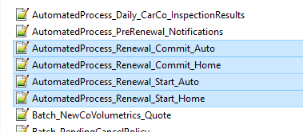

**Key Tasks:**

* **Policy renewal task:** The policies are picked by the batches based on the No. of days criteria mentioned in the “RenewalDays” table in manuscript “Carrier_AutomatedProcess_Renewal”.

Auto policy term: 6 months, Home Policy term: 1 Year

* **Premium calculation task**: “data.ProcessCheck” and “data.ProcessCheck_Commit” fields from “Carrier_AutomatedProcess_Renewal” manuscript are executed for the premium calculations.

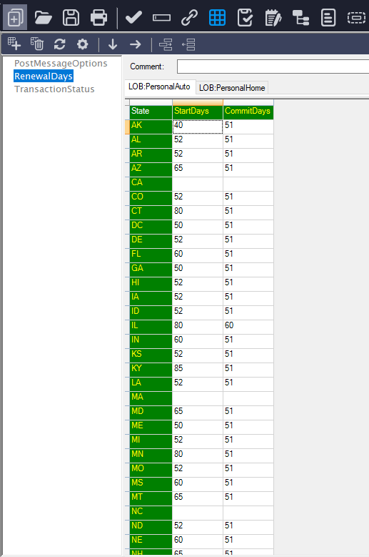 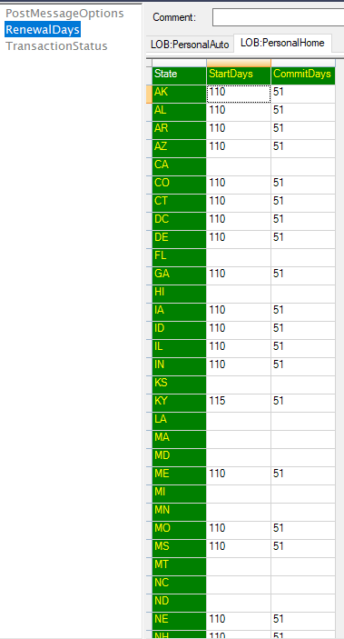

For Example:

When an Auto policy is of AK state,

Renew start batch must be initiated 40 days prior to the current term expiration date.

Renew commit batch must be initiated 51 days prior to the current term expiration date.

Similarly, when a Home policy is of AK state,

Renew start batch must be initiated 110 days prior to the current term expiration date.

Renew commit batch must be initiated 51 days prior to the current term expiration date.

Failure Analysis and Recovery:

Few policies might fail to Renew or Commit in the daily batches and must be analyzed and recovered.

We clone the policies in Debug environment and run the batch-script on those policies. Trace Monitor is used to analyze the failure reasons. Also, we can check the DCOD error logs to check for reasons of failure.

Policies can either be recovered in the back end via data fix/recovery scripts or Problem study team helps in the recovery.

Daily Report format:

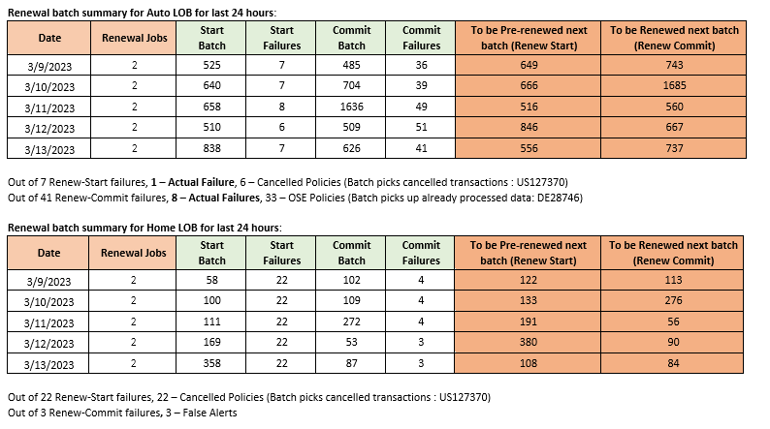

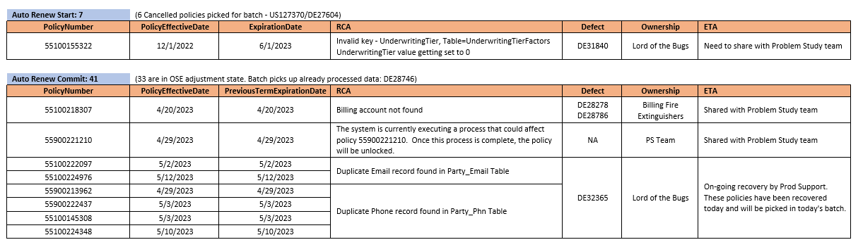

Overall, the goal of daily renewal batches is to streamline the policy renewal process and ensure that policies are renewed on time and with accurate information. This helps us to manage operations more efficiently and provide better service for our customers.

|  |  |  |
| --- | --- | --- |
| **SR .9** | **System Error** | **Digital Analytics , Glassbox & Query** |

## System Errors

**A) Transaction Count from DR DB vs No. of sessions with Error Page (It’s Not You. It’s us) for Internal/External users report**

**Description -** Team extract error page counts and percentage for Auto, Home & Service Portal (both internal & External). Perform Analysis for each error pages that exceeds the threshold value and raise defects with System Error Analysis report wherever required. Moreover, Team Monitors and assist the other team for the system error defects.

Note – We consider Data as Current day – 2 previous days

* Steps as follows

i) Firstly, Logon to Glassbox and you can find the count internal/External Count :

url - <https://glassbox.thehartford.com/webinterface/webui/#/reports/4918>

ii) PIP indicates the internal (No. of sessions with Error Page (It’s Not You. It’s us))

count and by adding the remaining states we get the external(No. of sessions with Error Page (It’s Not You. It’s us)) count.

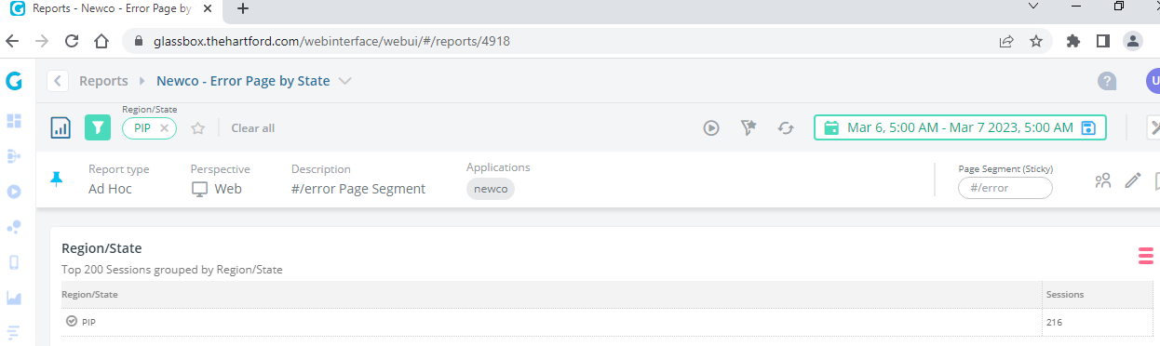

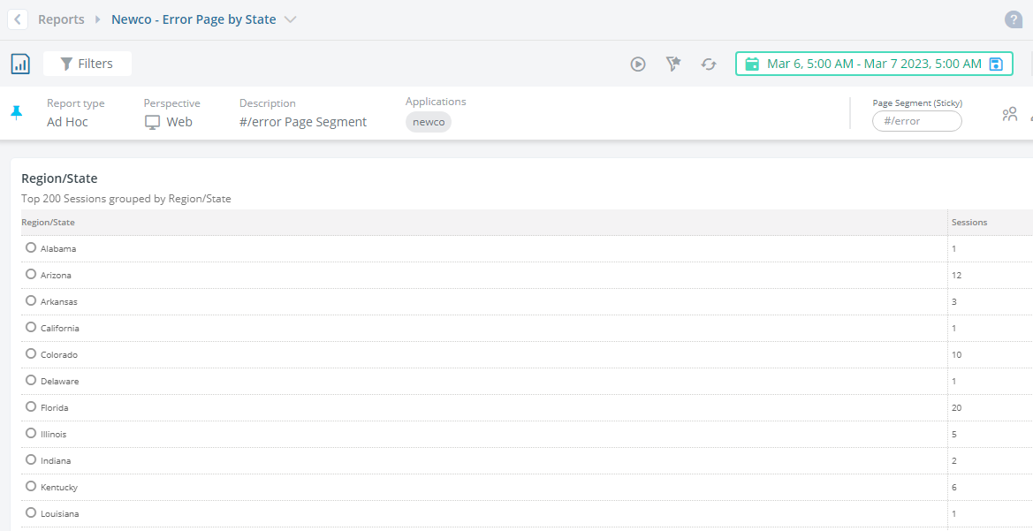

* Next , we have digital Analytics for Auto, Home & Service. Auto URL - <https://tableau/#/site/Digital/views/KnockoutsFormErrorsReport-60days/NewCoAuto-ErrorRatesByPage?:iid=1>
* Calculate the Total Errors and User Error Rate from the above URL and

consider the PageName whose User Error rate >=2 .

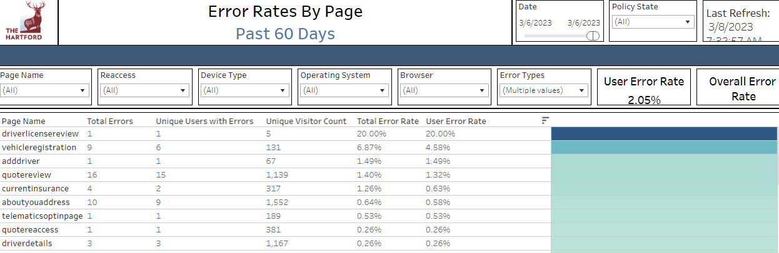

* Home URL - <https://tableau/#/site/Digital/views/NewCoHome-KnockoutFormErrors-90days/ErrorRatesbyPage?:iid=1>
* Calculate the Total Errors and User Error Rate from the above URL and consider the PageName whose User Error rate >=2 .

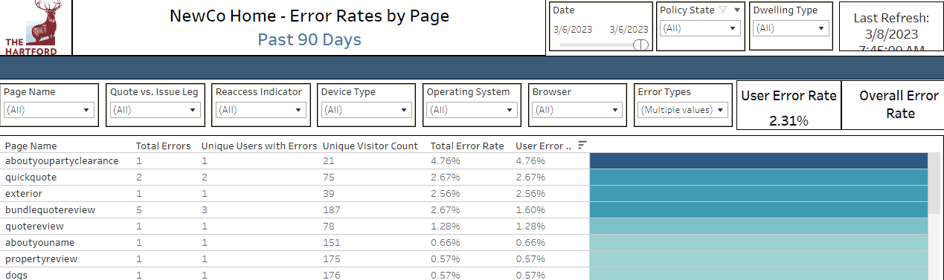

* Service URL - <https://tableau/#/site/Digital/views/NewCoServiceFormErrorReport/NewCoService-ErrorRatesByPage?:iid=1>
* Calculate the Total Errors and User Error Rate from the above URL and consider the PageName whose User Error rate >=2 .

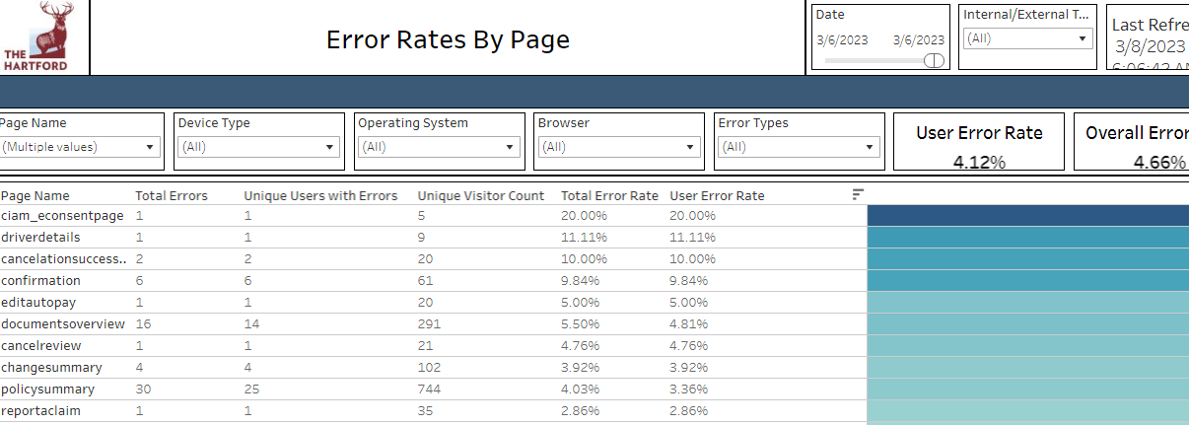

|  |  |  |
| --- | --- | --- |
| **SR .10** | **BRCC Balancing Issues & Balancing Issues** | **Email & SQL** |

## BRCC Balancing Issues

**Description -** This data is collected for the Reconciliation of the documents generated by BRCC and Requests made from HIG. In case of unexpected deviation in report and if the documents are not available, Team performs daily recovery or raise incident based on the number of instances.

* Approach - It is collected by extracting the Report sent from BRCC daily and cross checked with log of requests made from HIG.

Mail screenshot:

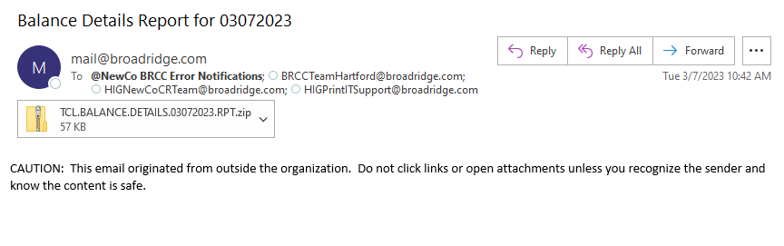

Extracted RPT file from BRCC Balance Details Report

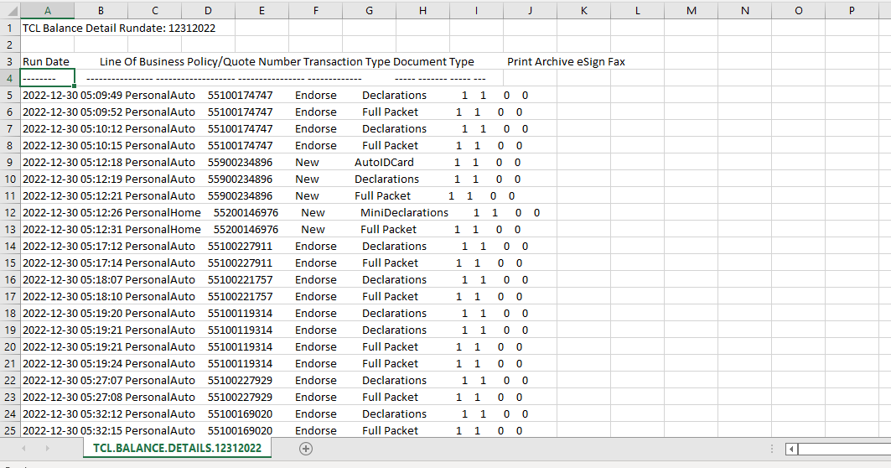

Report Screenshot

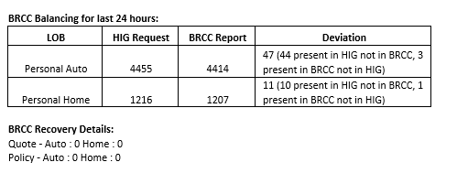

1. **Balancing Issues**

**Description -** This data is collected for Identifying the transactions of various components like TACT, POST, DIS, App2App, NPPS, EDO which are missing and are not balanced. Team works on Daily recovery of missing transactions.

* Approach: It is collected by running various SQL queries in different Database servers and cross validate those data.

Report Screenshot

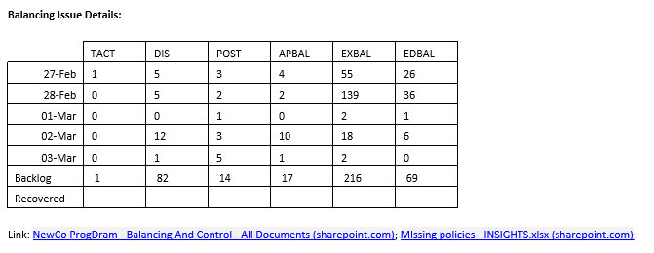

|  |  |  |
| --- | --- | --- |
| **SR .11** | **Certificate Upgrade** | **Email, RITM, SharePoint** |

## Certificate Upgrade

**Description -** The purpose of monitoring Certificate validity is to prevent the certificates from getting expired so that all the services remain up and running.

Team monitors the validity of certificates of all data power as well as on-prem services. Once any certificate is about to expire, or the password needs to reset – team gets an alert in NewCoCertCommunications and PL NewCo ProdSupport DL and acts on it accordingly.

* Approach

1. Once team gets intimation of any certificate expiration (before 30 days or more), they follow up with the vendor for gathering required data and raise RITM for Renewal. Once the certificate is installed before expiration date, team validates the same in web browser.

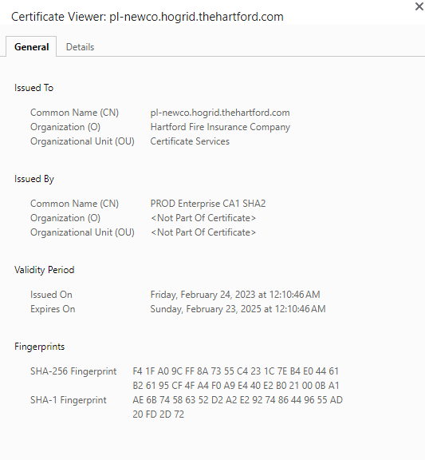

1. Followed by renewal, most of the time there is a deployment to update the new cert details in the respective layer (DataPower, F5 etc.). Post that, team validates the third-party services traffic (successful calls as well as failures) to ensure the cert upgrade is not impacting the business by any means. For On-Prem services, we get reference from Splunk Dashboard as well to get service traffic. (PL Account Linking, Sales Router etc.).

Validations for Third Services

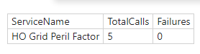

Validations for HIG Internal Services

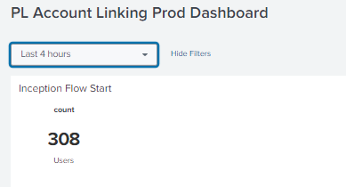

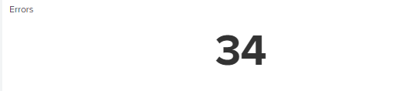

1. Team validates the Glassbox sessions to ensure successful quote/policy creation or account linking post the upgrade.

For daily monitoring, we track all the certificate related details in SharePoint and show those certificate details which are about to expire in daily health report.

Link of Cert Upgrade Details: [3PD_CertUpdates.xlsx](https://thehartford.sharepoint.com/:x:/r/sites/NewCoProgram/Execution/Production%20Support/3PD/3PD_CertUpdates.xlsx?d=wb15828149ec944d0839de4519da2359f&csf=1&web=1&e=t3yke0)

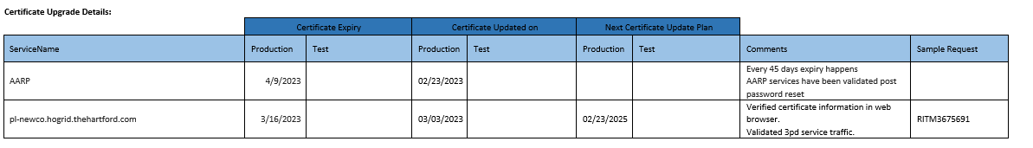

|  |  |  |
| --- | --- | --- |
| **SR .12** | **MTE Extract** | **MTE** |

## MTE Ticket Extract Report

**Description -** Here, Team extracts lists of incidents raised on daily basis from MTE Portal. Bifurcated as Auto Generated & Self Service. Performs analysis if the incidence hold unknown issue.

* Steps to create Report

1. Go to MTE URL
2. Search for reports in search pane and then select View/Run

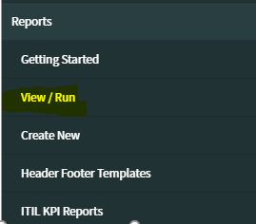

1. Click on group, and then select “Self

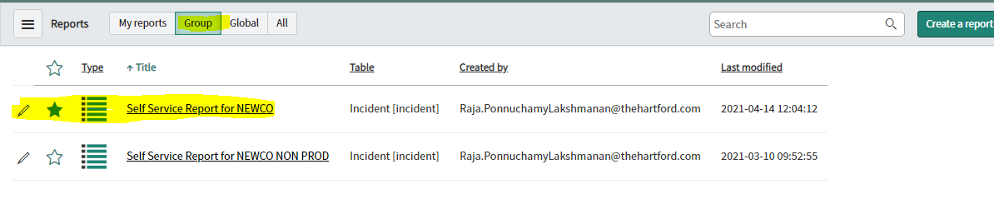

1. Right click next to Number and select export -> excel option

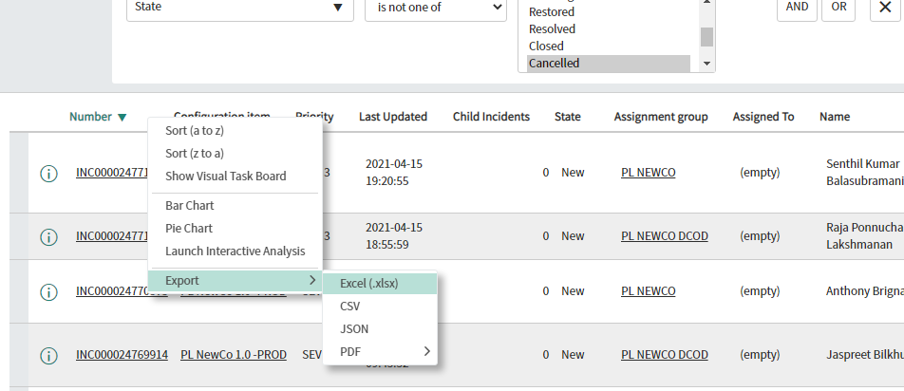

1. 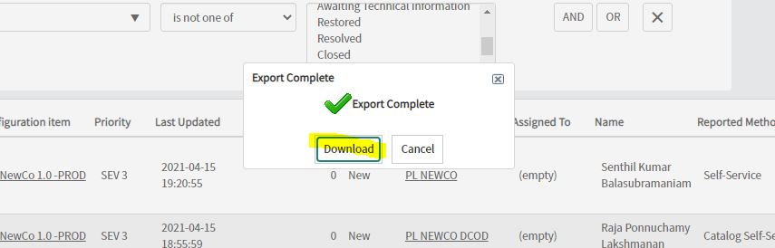 Open the downloaded excel
2. To create below table for PL NewCo PROD, follow the steps from a to f

|  |  |  |
| --- | --- | --- |
| **Source** | **Count of Tickets** | **Reported in last 24 Hrs. (prev. date and current date)** |
| Auto Generated | A | B |
| Self-Service (User reported/ Virtual Agent) | C | D |
| **Grand Total** | **A+C** | **B+D** |

a) Filter, Configuration items as Prod

1. To find A, filter out records, select Ticket created date from April(all dates) and blanks, then apply filter on Reported method column-> select “Auto-generated”, write the count in place of A
2. To find B, filter out records as, select Ticket created date as prev. date (current date -1) and current date. In the Reported method column -> select “Auto-generated”, write the count in place of B
3. To find C, select Ticket created date as April(all dates) and blanks, then apply filter on Reported method column-> select ”Catalogue self -service”, “Self-service”, “Virtual agent” and “service desk phone” , write the count in place of C
4. To find D, filter out records as, select Ticket created date as prev. date (current date -1) and current date, then apply filter on Reported method column-> select ”Catalogue self -service”, “Self-service”, “Virtual agent” and “service desk phone”, write the count in place of D
5. To create below table, use the same filters as are given in step e, and filter status based on “state” column

Note -- For DCOD stat, repeat the steps from step a to f but select Assignment group as PL NEWCO DCOD

|  |  |  |
| --- | --- | --- |
| **SR .13** | **SF Details** | **Duck Creek Force** |

## SF Details

**Description -** Team is tracking SF tickets raised on DCT for any Production Issues, SQL script execution, Access etc. Also, Verifies if the status Defect is “Waiting on Customer” and tracks the progress.

* Follow below steps to fetch SF details, note you should have access to SF portal for extracting this data:

1. Login to [this](https://duckcreek.force.com/DCTSupport/s/login/) URL
2. Navigate to ‘Customer Report’ tab as shown below:

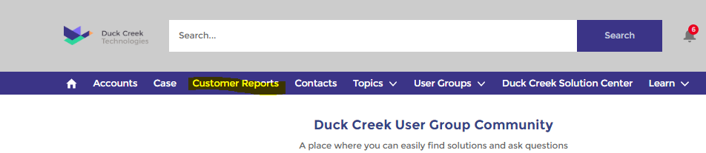

1. Select values as: Account Name = Hartford, Cases Created After = 1/1/2022 & Status = take all statuses except Resolved & Closed. Please see image below:

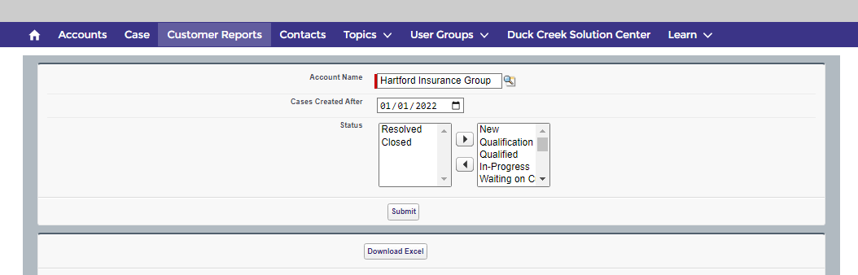

1. Click on ‘Submit’ button
2. Click on ‘Download Excel’ button
3. Open the downloaded excel, change font size as required and perform following steps:
4. Hide all the columns from ‘B’ to ‘G’, ‘I’ and ‘J’, ‘L’ , ‘M’, ‘N’
5. - Filter on column ‘K’ (Created By) and select PS Team members ONLY
6. - Select columns ‘A’, ‘H’, ‘K’ & ‘O’ and this forms our first table. Example shown below

Note - Team follow up with DCOD team and responds if there is any SF ticket with status as ‘Waiting On Customer’

|  |  |  |  |
| --- | --- | --- | --- |
| **Case Number** | **Status** | **Created By** | **Subject** |
| 228812 | Qualification | Arka Sarkar | Unable to raise any ODCH with the xml file having tag inline |
| 228687 | Qualification | Nilesh Datir | Request to reset password for DR DB (user: MayuriM) |
| 228516 | Qualified | Kishore Patturi | Need SalesForce access to Kevin Bodie |
| 227445 | Waiting on Customer | Carlos Aponte | Event Viewer Logs CC_PAYMENTS error |
| 225123 | In-Progress | Preetam Bharambe | Spike in 500 Internal Server Error on 7/22 around 5:30pm |
| 224861 | Waiting on Customer | Carlos Aponte | Event Viewer Logs for PROCESS_PCN |
| 222889 | Development | Nilesh Datir | Fees not getting Auto WriteOff on the SINV execution which scheduled after FCAN |
| 222718 | Waiting Internally | Akila Rajasekaran | Insights - Timeout error spike |
| 219871 | In-Progress | Akila Rajasekaran | Request to install TAC in UEUAT28JMPBX01 |
| 218526 | Waiting Internally | Carlos Aponte | Add Alert and Monitoring for New Billing Jobs - July Release |
| 211846 | Development | Arka Sarkar | The timestamp being reflecting in Activity Stream Section of Customer 360 is that of UTC instead of current system datetime for selected policy |

|  |  |  |
| --- | --- | --- |
| **SR .14** | **External Security Check** | **Hartford URL** |

## External Security Checks

**Description –** Team test Hartford External/Internal URL from Non-USA VPN and expected resulted is “User should not be able to proceed with New Quote”.

|  |  |  |
| --- | --- | --- |
| **SR .15** | **IP Address** | **Tableau & Digital Analytics** |

## IP Tracking

**Description -** We need to extract the Distinct QCNs by  IP Address (Total) for Auto, Home & Service Portals –

Auto URL – *https://tableau/#/site/Digital/views/NewCoAutoIPAddressTracking/Overview?:iid=1*

Can set the date for the previous day and click on download

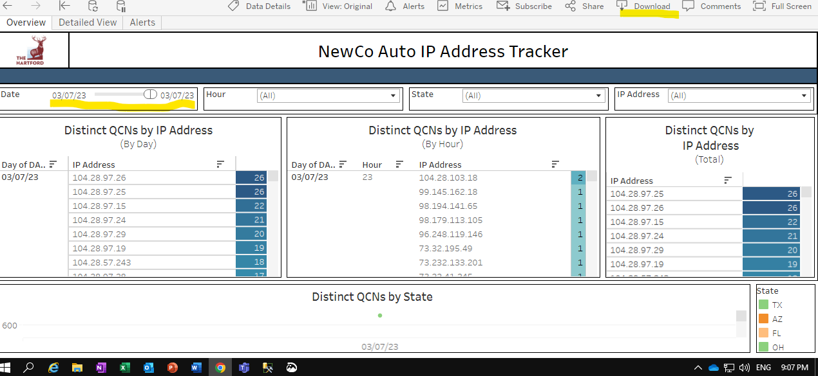

Home URL – [*https://tableau/#/site/Digital/views/IPAddressTracker/Overview?:iid=2*](https://tableau/#/site/Digital/views/IPAddressTracker/Overview?:iid=2)

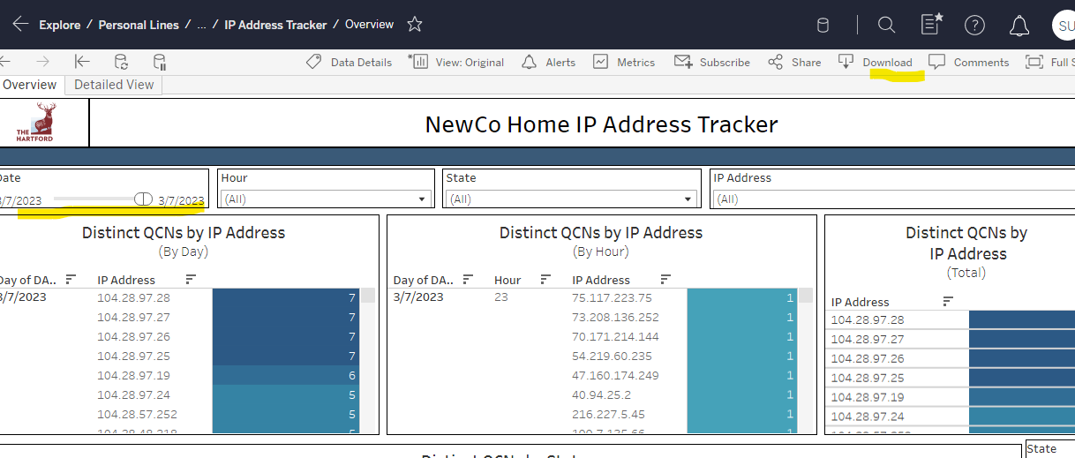

Note - If the count is >5 then we need to do the Analysis by going thru the Glassbox sessions.

|  |  |  |  |
| --- | --- | --- | --- |
| **SR .16** | **MFT Job Status – On Prem & Billing** | **MFTPortal** |  |

## MFT Job Status – On Prem

**Description -** MFT Status are collected based on the MFT IDs.

* Below are the steps to check the MFT Job Status:

1. Open the MFT Portal: <https://mftportal.thehartford.com:9443/security/login>
2. After Entering username and password click on the search Button on the left side
3. Enter the MFT ID in LOB/Department/Owner/MFTID Text box
4. In Process Start Date there are two textboxes From and To.
5. From will be having value of (T-1) day
6. To will be having value of T day
7. In LOB/Department/Owner/MFTID Text box enter the value in the format(*MFTID*) and click on Search
8. Ensure "ProcStatus" is "Success" and Check the column “ProcEndDate” and update the latest date in excel
9. Please find the below link for the On-prem MFT Id details –

[MFT_Onprem.xlsx (sharepoint.com)](https://thehartford.sharepoint.com/:x:/r/sites/NewCoProgram/_layouts/15/Doc.aspx?sourcedoc=%7B7A8C5A54-6963-4821-8B36-796C2608EA17%7D&file=MFT_Onprem.xlsx&action=default&mobileredirect=true)

1. If the MFTID gets failed, then we need to check the reason why it got failed and should take the necessary action to get the report MFTed successfully.
2. Team is tracking the daily ON-Prem MFT details in the below link –

[On Prem MFT Job Status.xlsx (sharepoint.com)](https://thehartford.sharepoint.com/:x:/r/sites/NewCoProgram/_layouts/15/Doc.aspx?sourcedoc=%7B4C1BFB8C-5E90-4DF7-96C9-18CF2824D106%7D&file=On%20Prem%20MFT%20%20Job%20Status.xlsx&action=default&mobileredirect=true&cid=bf511053-ca86-4b05-b2cd-2998de8e9585&CID=2C804C30-A8E5-43E1-8CB1-5BF18F5A21D2&wdLOR=c32A80807-08DE-43C7-8AE4-CE0C4D07BA8F)

* **Observations and validations:-**

1. We need to ensure that the reports got generated for the respective MFT ID in the SharePoint link mentioned in Point no 9. If the report is generated successfully, then the report gets archived in the Archive -> Outbound folder.
2. Sometimes policies are rejected by the Vendor which will be available in the Prod Inbound path for APP2APP reports.
3. If we find any issues while the reports getting generated, then the team will analyze the issue and take the necessary actions to get the reports generated successfully.
4. **MFT Job - Billing**

**Description -** MFT Status are collected based on the MFT IDs.

* Below are the steps to check the MFT Job Status:

1. Open the MFT Portal: <https://mftportal.thehartford.com:9443/security/login>
2. After Entering username and password click on the search Button on the left side
3. Enter the MFT ID in LOB/Department/Owner/MFTID Text box
4. In Process Start Date there are two textboxes from and to.
5. From will be having value of t-1 day
6. To will be having value of t day
7. In LOB/Department/Owner/MFTID Text box enter the value in the format(*MFTID*) and click on search
8. Ensure "ProcStatus" is "Success" and Check the column “ProcEndDate” and update the latest date in excel
9. Please find the below link for the On-prem MFT Id details –

[MFT_Onprem.xlsx (sharepoint.com)](https://thehartford.sharepoint.com/:x:/r/sites/NewCoProgram/_layouts/15/Doc.aspx?sourcedoc=%7B7A8C5A54-6963-4821-8B36-796C2608EA17%7D&file=MFT_Onprem.xlsx&action=default&mobileredirect=true)

|  |  |  |
| --- | --- | --- |
| Billing Jobs | MFTID | Status on MFT |
| ACH Payment Process request | NCBA4P | Success for 10/28 |
| ACH Refunds Process request | NCBA4P | Success for 10/28 |
| CC Payment Process request | NCBA4P | Success for 10/28 |
| CC Refund Process request | NCBA4P | Success for 10/28 |
| ACH Return Payment Process | NCBA3P | Success for 10/28 |
| ACH Return Refund Process | NCBA3P | Success for 10/25 |
| CC Return Payment Process | NCBA2P | Success for 10/28 |
| CC Return Refund Process | NCBA2P | Success for 10/28 |
| DCS Check Refunds File transfer | NCDCS1P | Success for 10/28 |
| DCS Check Refunds Details and Status update via DCS Feedback Process | NCFTNB1P | Success for 10/29 |
| FEED file transfer (MonthlyExpenseFeed) | NCET1P | Success for 10/31 |
| ABA Routing Numbers / Monthly update from BACIS | NEAB1 | Success for 10/25 |

|  |  |  |
| --- | --- | --- |
| **SR .17** | **Quote Issue Volume Count** | **Splunk Dashboard** |

## New Volumetric Prod Dashboard

**Description -** Team validates the Quote/Issue traffic counts on daily basis through this dashboard. If considerable amount of deviation found, then team verifies the other monitoring components to understand if anything impacting Newco Customers to access the application or commit the quote (E.g., service down, application unavailability etc.) and raise incident accordingly.

This dashboard provides total Volumetric Count, Count By State, Count By LOB, Count By Status, Count By Time, Count by Agency, LOB Count By State, LOB Count By Status, Status Count By State.

URL: [NewCo_Volumetric | Splunk 9.0.2209.4 (splunkcloud.com)](https://thehartford.splunkcloud.com/en-US/app/HIG_APP_PL/newco_volumetric?form.field1.earliest=-24h%40h&form.field1.latest=now)

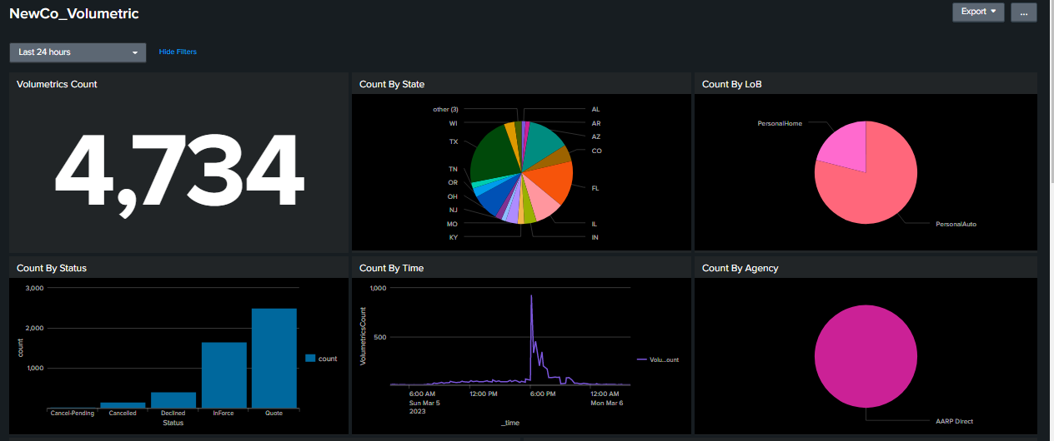

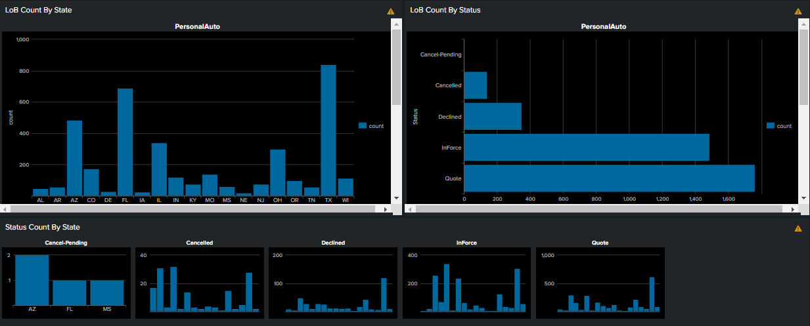

|  |  |  |
| --- | --- | --- |
| **SR .18** | **Grafana** | **Splunk Dashboard** |

## Grafana for Performance

**Description -** Using this dashboard, team validates the User Action Performance Trends. This Dashboard consists of Performance Trend (By 90 Percentile), Volume Trend.

URL: [NewCo Production - User Action Performance Trends - Grafana](http://wad1prfhd2010:3000/d/yUKwT9A7z/newco-production-user-action-performance-trends?orgId=1)

